EcoPlay: A Gamified Web-Based Environmental Education Platform for School Students

Mahalakshmi R K
Department of Computer Science and Engineering
Presidency University
Bangalore,Karnataka
Sushmitha N
Department of Computer Science and Engineering
Presidency University
Bangalore,Karnataka
Lathashree
Department of Computer Science and Engineering
Presidency University
Bangalore,Karnataka

Abstract—Environmental degradation and unsustainable behaviour patterns among school-age populations represent a pressing global concern. Conventional classroom-based environmental education is largely passive and fails to translate ecological awareness into measurable real-world action. This paper presents EcoPlay, a web-based gamified environmental education platform designed to foster eco-consciousness and sustainable behaviour among school students through game mechanics including a points engine, tiered quizzes, real-world photo-verified challenges, and a competitive leaderboard. Built on Python Flask with SQLite persistence, EcoPlay supports two distinct roles — school administrators (teachers) and students — each with dedicated dashboards and workflows. A pilot deployment with six student users demonstrated 67% active participation, 18 completed quiz levels, and 82 cumulative points across ten environmental categories. Functional testing across ten test cases confirmed 100% pass rate. Results validate that gamification can bridge the gap between environmental knowledge and measurable behavioural action at the institutional level.
Index Terms — Gamified learning, environmental education, Python Flask, SQLite, leaderboard, eco-challenges, quiz engine, school platform, points system.

- Introduction

The United Nations Sustainable Development Goals (SDGs) — particularly SDG 4 (Quality Education) and SDG 13 (Climate Action) — emphasise the foundational role of education in building environmentally responsible citizens [1]. Despite widespread access to environmental knowledge through textbooks and digital media, behavioural change among young learners remains elusive. Students encounter ecological topics in classrooms but rarely in formats that motivate consistent, measurable real-world action.
Gamification — the deliberate application of game-design elements to non-game contexts — has emerged as a compelling pedagogical strategy. Deterding et al. define gamification as the use of elements such as points, leaderboards, challenges, and reward loops to drive

engagement [3]. Hamari et al. demonstrated through a systematic review of 24 empirical studies that gamification consistently improves student motivation and learning outcomes, particularly when social comparison features such as leaderboards are present [4].
Existing environmental education tools — such as JouleBug, EcoChallenge, Kahoot!, and Quizizz — address isolated aspects of the problem but lack the institutional role management, photo-verified real-world challenge workflows, and teacher-facing analytics that school-level deployment demands. EcoPlay addresses this gap by integrating instructional eco-activities with embedded video, tiered quizzes, real-world challenges, gamified rewards, and a comprehensive Teacher Report Dashboard into a single Flask-SQLite web application.
This paper presents the design, implementation, and evaluation of EcoPlay. Section II reviews related work. Section III describes the system architecture and design. Section IV details the implementation. Section V presents experimental results. Section VI discusses findings and limitations. Section VII concludes with future directions.

II. RELATED WORK

A. Gamification in Education
Deterding et al. [3] established the foundational framework for gamification, arguing that game mechanics must be aligned with learning objectives to generate genuine engagement rather than superficial interaction. Hamari et al. [4] found positive gamification effects in over 57% of reviewed studies, with social comparison mechanics — notably leaderboards — being among the most reliably effective individual components.
Dichev and Dicheva [5] caution that extrinsic reward structures can undermine intrinsic motivation over time. EcoPlay addresses this concern by tying all point awards directly to genuine learning outcomes: quiz correctness and verified completion of real-world eco-challenges, rather than arbitrary engagement metrics.

B. Environmental Education Platforms
JouleBug and EcoChallenge target adult behaviour change via mobile apps but lack school-curriculum alignment and teacher-mediated management workflows. Aziz et al. [6] reported a 34% improvement in self-reported eco-behaviour using a gamified mobile app for university students; however, their platform lacked institutional role management, teacher dashboards, and submission-verification workflows that are central to EcoPlay's design. Kahoot! and Quizizz offer quiz-based engagement but provide no domain-specific environmental content and no real-world challenge integration.
C. Web Application Frameworks for EdTech
Flask-based web applications have gained adoption in educational technology for their lightweight architecture and rapid prototyping speed [7]. SQLite provides embedded persistence without a separate database server, making it appropriate for single-institution school deployments. Session-based authentication is well-established for small-scale educational portals where lightweight security is acceptable for pilot deployments.

III. SYSTEM DESIGN AND ARCHITECTURE

A. Three-Tier Architecture
EcoPlay follows a three-tier client-server architecture. The Presentation Tier comprises Jinja2 HTML templates rendered server-side and delivered to both student and administrator browsers. The Application Tier is a Python Flask application (app.py) encapsulating all route handlers, business logic, session management, and file-upload processing. The Data Tier is an SQLite database (database.db) storing all persistent entities. File assets — instructional videos and student challenge photo submissions — reside on the local filesystem under /static/ and are served directly by Flask.
All HTTP requests from student and administrator clients are resolved by Flask route handlers, which execute parameterised SQL queries against SQLite and return Jinja2-rendered HTML responses. The Gamification Module — comprising the points engine, leaderboard computation, and quiz scoring logic — is implemented entirely within Flask route handlers, requiring no external services or message queues.
B. Role-Based Access Control
EcoPlay implements two roles. School Administrators (teachers) access the School Dashboard, Manage Activities, Student Verification, Challenges, Create Quiz, and Reports modules. Students access the Student Dashboard, Available Activities, Challenges, Quiz Engine, and Leaderboard. Role

assignment is persisted in the users table's role field and verified via Flask session on every protected route. Unauthenticated requests redirect to the login page.
C. Database Schema
The SQLite database contains eight core tables. The users table stores teachers and students distinguished by the role field, alongside verification_status and cumulative points. activities stores instructional eco-tasks with category, difficulty, points value, date range, and paths to uploaded video, materials text, and step-by-step instructions. challenges and challenge_tasks record real-world eco-challenges and their sub-tasks. challenge_submissions stores student photo evidence with approval status. quiz_questions holds a categorised, levelled question bank (Beginner/Intermediate/Advanced) with four-option MCQ format. quiz_attempts records per-session scores for analytics. completed_levels tracks which category-level pairs each student has finished.

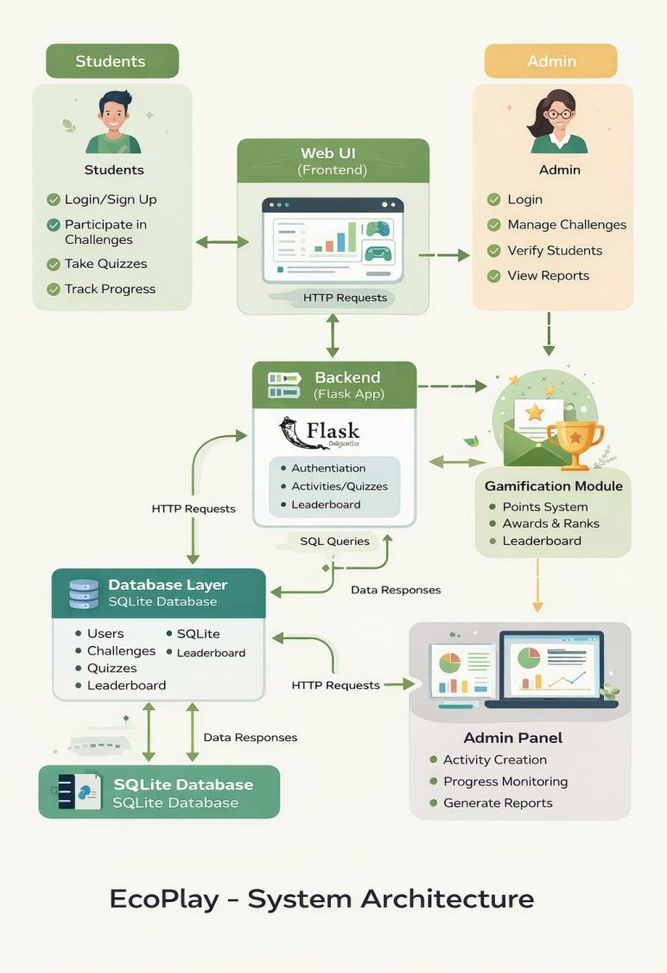
Fig. 1. EcoPlay System Architecture — three-tier client-server design showing Student and Admin roles, Flask backend, Gamification Module, Admin Panel, and SQLite database layer.

IV. IMPLEMENTATION

A. Technology Stack
TABLE I
EcoPlay Technology Stack
Layer | Technology | Purpose
Backend | Python Flask 2.x | Routing, logic, sessions
Database | SQLite 3 | Embedded persistence
Templating | Jinja2 HTML | Server-side rendering
Styling | Custom CSS | Gamified UI design
Auth | Flask Sessions | Role-based access
File Storage | Local /static/ | Videos & photo uploads

B. Authentication and User Management
User authentication is implemented via Flask session cookies. On successful login the user's id, name, and role are stored in session. The login route (GET /) renders the login form; POST validates credentials against the users table using parameterised SQL to prevent injection. Signup creates a record with role='student', verification_status='pending', and points=0. The Student Verification module allows teachers to approve or reject pending registrations, updating verification_status accordingly.
C. Quiz Engine
The quiz engine (/quiz/<category>/<level>) selects five random questions from quiz_questions matching the specified category and difficulty level using case-insensitive parameterised SQL queries. Question IDs are stored in Flask session to prevent answer substitution between request cycles. On submission, each response is compared against correct_answer; each correct match increments the user's points. A quiz_attempts record is inserted for analytics, and the completed category-level pair is logged in completed_levels.
D. Challenge and Submission System
Teachers create challenges specifying title, description, category, difficulty, points, date range, and a newline-delimited task list; each task is stored as a separate challenge_tasks record linked by challenge_id. Students upload a photo for each task; images are saved to /static/uploads/ with Unix-timestamp prefixed filenames to prevent collisions. Teachers review submissions via /view_submissions and approve or reject individual entries, updating challenge_submissions.status.
E. Gamification and Leaderboard
The points engine awards one point per correct quiz answer and ten points per activity marked as learned. The /leaderboard route queries all students ordered by points DESC. The top three students are presented in gold, silver,

and bronze podium cards; the remaining students appear in a
full ranked table with medal emoji indicators for positions one through three.

V. EXPERIMENTAL RESULTS

A. System Screenshots
Figure 2 shows the EcoPlay login page featuring the gamified nature-themed background with a role selector for Student or Admin access. Figure 3 shows the Student Dashboard presenting four quick-action cards — Activities, Challenges, Quiz, and Leaderboard — followed by the list of available eco-activities with point values and date ranges.

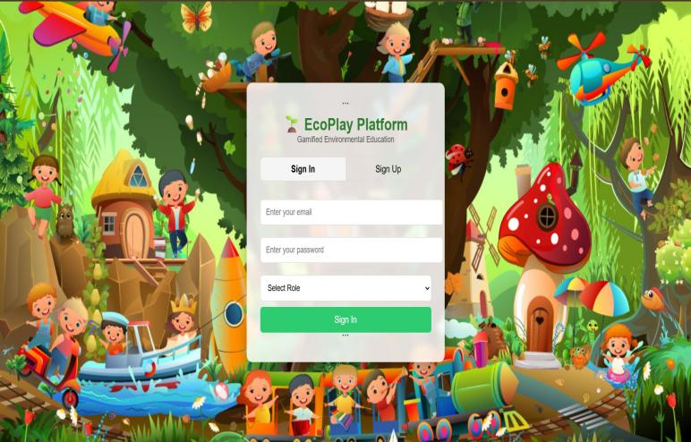

Fig. 2. EcoPlay Login Page — Gamified nature-themed interface with email, password, and role-selector fields.

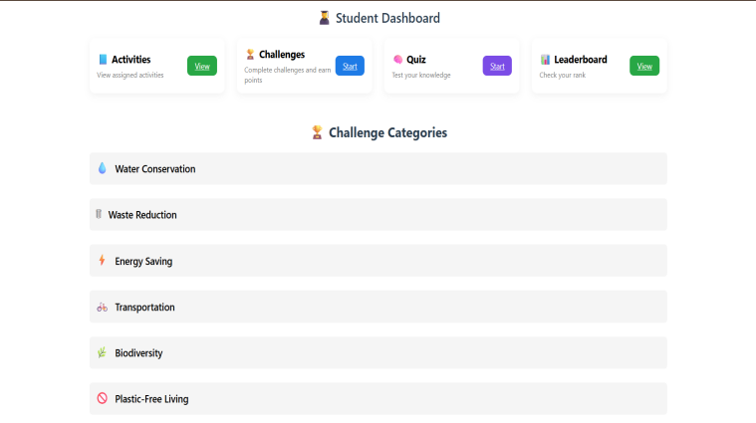

Fig. 3. Student Dashboard — quick-action cards for Activities, Challenges, Quiz, and Leaderboard, followed by available eco-activities with points and date ranges.

B. Pilot Deployment Results
EcoPlay was deployed in a controlled pilot with six student users under the supervision of a school administrator. Three instructional activities were created across Water Conservation, Biodiversity, and Energy Saving categories. Four real-world challenges of intermediate to advanced difficulty were created across Green Lifestyle, Waste Reduction, Energy Saving, and Plastic-Free Living. The quiz question bank was populated across all ten environmental categories at Beginner, Intermediate, and Advanced levels.
TABLE II
Pilot Deployment — Student Engagement Summary
Student | Points | Quiz Levels | Challenges | Activities | Status
Vaishnavi R | 30 | 5 | 2 | 2 | Active
Sushmitha N | 25 | 4 | 1 | 2 | Active
Mahalakshmi R K | 17 | 4 | 1 | 1 | Active
Varsha D | 10 | 3 | 1 | 1 | Active
Lathashree N | 0 | 0 | 0 | 0 | Inactive
Kavya D K | 0 | 0 | 0 | 0 | Inactive

Across the pilot cohort, 4 of 6 students (67%) became active participants, collectively accumulating 82 points across 18 completed quiz levels. The leaderboard correctly ranked all six students by cumulative points. The Teacher Report Dashboard accurately aggregated quiz accuracy rates, challenge completion counts, and the Weak Students list — correctly identifying the two inactive students for targeted teacher follow-up.
C. Functional Test Results
TABLE III
Functional Test Case Results — 10/10 Pass
TC# | Module Under Test | Expected Outcome | Result
TC-1 | Student Registration | Record inserted with pending status, points=0 | Pass
TC-2 | Teacher Login | Session set (user_id, role); redirect to /dashboard | Pass
TC-3 | Create Activity + Video | DB record created; video saved to /static/videos/ | Pass
TC-4 | Student Approval | verification_status updated to 'verified' | Pass
TC-5 | Category Quiz Submit | Score computed; points added; completed_levels recorded | Pass

TC-6 | Challenge Photo Upload | Image saved; challenge_submissions record inserted | Pass
TC-7 | Leaderboard Ranking | Students ordered by points DESC; top 3 highlighted | Pass
TC-8 | Report Dashboard | Correct counts for students, activities, quiz, accuracy | Pass
TC-9 | Delete Activity | Record removed; redirect to /manage_activities | Pass
TC-10 | Logout | Session cleared; redirect to login page | Pass

D. System Performance
All pages loaded within 1.5 seconds on a local network during testing with up to 10 concurrent browser sessions. SQLite read operations for the leaderboard and report aggregation queries completed in under 50 milliseconds for the pilot dataset of 6 students. Activity video streaming from the local filesystem was adequate at pilot scale; horizontal scalability would require migration to a shared database (e.g., PostgreSQL) and cloud object storage for multi-school deployment.

VI. DISCUSSION

A. Effectiveness of Gamification Mechanics
The 67% active participation rate supports the hypothesis that gamification mechanics effectively motivate school students in environmental education contexts, consistent with the findings of Hamari et al. [4]. The leaderboard correlated with higher point accumulation among the top four students. The Weak Students identification feature on the Teacher Report Dashboard correctly flagged the two inactive students for intervention, demonstrating the teacher-support value of the analytics module.
The integration of real-world, photo-verified challenges proved particularly significant. Unlike passive quiz completion, challenge submissions required tangible eco-actions — water filtration experiments, plastic-free days, and seed germination activities — connecting digital point accumulation to observable environmental behaviour. This aligns with findings by Aziz et al. [6] that gamified platforms with real-world action components produce stronger behaviour change than quiz-only formats.
B. Limitations and Security Considerations
The pilot cohort of six students is insufficient for statistically robust conclusions regarding long-term behavioural impact. Passwords are stored in plaintext in the current

implementation — a critical security gap that must be resolved before any production deployment via bcrypt or Argon2 hashing. Photo submissions are currently served without authentication-gating, creating potential privacy risks given that users may be minors. The weak-student threshold of 50 points is hard-coded and may not generalise across schools with different activity volumes. The Teacher Report Dashboard's activity distribution chart showed a minor rendering issue with the tree category count due to a mismatched SQL category label.

VII. FUTURE WORK

Several enhancements are planned for future iterations. Multi-school support requires a super-admin role and school_id isolation to enable inter-school leaderboard comparisons. Password hashing via bcrypt is a prerequisite for any production deployment. A React Native or Flutter mobile application would improve student accessibility on smartphones. AI-powered quiz generation using a large language model API would reduce the manual quiz-creation burden on teachers significantly. Digital badge and achievement systems — for example, a Water Warrior badge for completing five water conservation activities — would enrich the gamification layer beyond points alone. Cloud deployment on a renewable-energy provider with HTTPS enforcement and PostgreSQL migration would address both scalability and security concerns at institutional scale.

VIII. CONCLUSION

This paper presented EcoPlay, a gamified web-based environmental education platform designed for school students. The system integrates points, leaderboards, photo-verified real-world challenges, and tiered quizzes across ten environmental categories within a unified Flask-SQLite application supporting both teacher and student roles. A pilot deployment demonstrated 67% active participation and confirmed that all ten core functional requirements were satisfied. The Teacher Report Dashboard provides actionable, data-driven insights enabling teacher-led intervention for less engaged students. EcoPlay demonstrates that gamification can serve as an effective bridge between environmental knowledge and measurable, real-world sustainable action at the school level, directly contributing to SDG 4 and SDG 13 objectives. Future work will address multi-school scalability, mobile deployment, and AI-powered content generation.

References

[1] United Nations, "Transforming our world: the 2030 Agenda for Sustainable Development," UN Department of Economic and Social Affairs, 2015. [Online]. Available: https://sdgs.un.org/goals
[2] Ministry of Electronics and Information Technology, Govt. of India, "Digital Personal Data Protection Act, 2023," Gazette of India, 2023.
[3] S. Deterding, D. Dixon, R. Khaled, and L. Nacke, "From game design elements to gamefulness: defining gamification," in Proc. 15th Int. Academic MindTrek Conf., 2011, pp. 9–15.
[4] J. Hamari, J. Koivisto, and H. Sarsa, "Does gamification work? A literature review of empirical studies on gamification," in Proc. 47th Hawaii Int. Conf. System Sciences, 2014, pp. 3025–3034.
[5] C. Dichev and D. Dicheva, "Gamifying education: what is known, what is believed and what remains uncertain: a critical review," Int. J. Educational Technology in Higher Education, vol. 14, no. 1, pp. 1–36, 2017.
[6] N. A. Aziz, M. S. Mustafa, and S. F. M. Safri, "Gamified mobile application for environmental awareness among university students," Int. J. Advanced Science and Technology, vol. 29, no. 4, pp. 1342–1351, 2020.
[7] M. Grinberg, Flask Web Development: Developing Web Applications with Python, 2nd ed. O'Reilly Media, 2018.
[8] A. Bhargava, A. Shukla, O. P. Goswami, M. H. Alsharif, P. Uthansakul, and M. Uthansakul, "Plant Leaf Disease Detection, Classification, and Diagnosis Using Computer Vision and Artificial Intelligence: A Review," IEEE Access, vol. 12, pp. 37443–37469, 2024.
[9] A. Kohn, Punished by Rewards: The Trouble with Gold Stars, Incentive Plans, A's, Praise, and Other Bribes. Houghton Mifflin Harcourt, 1999.
[10] Statista Research, "Number of smartphone users in India from 2015 to 2025," Statista, 2024.

